1. Can we send an email without a subject?

1. yes
2. no
3. it depends on the email client
4. it depends on the mailing services

2. What will be output of the following pseudocode?

Start

Declare Integer x

Set x = 1

while ( x < 20 )

Print x

x = x *5

End while

1. It prints all multiples of 5 between 1 and 100 (including both 1 and 100)
2. It prints all multiples of 5 between 1 and 100 (excluding both 1 and 100)
3. It prints all multiples of 5 between 1 and 20 (including both 1 and 20)
4. None of the mentioned options

3. The 2's compliment of 101101 is:

1. 101100
2. 100011
3. **010011**
4. 110011

4.Which of the following syntax represents a root directory?

1. c:\\
2. c\:
3. c\:\
4. c:\

5. Which of the following are the disadvantages of File management system?

1. Does not support multi-user access
2. Redundancy and integrity issues
3. Requires highly skilled administrators

choose the correct answer from the options given below.

1. only 1 and 2
2. only 2 and 3
3. only 1 and 3
4. all 1, 2 and 3

6.Which of the following is used to represent attributes in a table in DBMS?

1. Row
2. All of the mentioned options
3. Column
4. Record

7.Which of the following is the default view of "Microsoft Word 2010"?

1. web layout view
2. outline view
3. headline view
4. print layout view

8.what will be the output of the following pseudocode for n = 5?

Integer n, i = 3 , count, c

Input n

for count=2 up to n

for c = 2 up to i - 1

if ( i % c equals 0 )

Go out of the loop

end for

if ( c equals i)

print i

count = count + 1

end if

end

1. 2 4 7 9 13
2. 2 3 5 7 11
3. 2 4 6 8 12
4. None of the mentioned options

9. Using which of the following protocols, one can get files from another computer?

1. HTTP
2. FTP
3. ARP
4. UTP

10.An ER-Model is based on:

1. Entities and their attributes
2. Relationships among entities
3. Only 1
4. only 2
5. Neither 1 nor 2
6. Only 1 and 2

11.Which of the following is/are possible in database management system to relate one or more records to one-other?

1. More than one table record relates to another table record
2. All of the mentioned records
3. One table record relates to many records in another table
4. One table record relates to another record in another table

12.If an entity has a primary key, it can be called as:

1. primary entity
2. strong entity
3. weak entity
4. primary key

13.The ALU of a computer normally contains which of the following high-speed storage elements?

1. magnetic disks
2. semiconductor memories
3. registers
4. hard disks

14.Which of the following can be attached to the email?

1. word document
2. images
3. power point presentation
4. audio/video files

choose the correct answer from the options given below.

1. only 1 and 2
2. only 1, 2, and 3
3. only 1
4. All 1,2 ,3 and 4

15.Which of the following statements is/are true about the .pps extension?

1. A file in .pps cannot be converted into a file in .ppt
2. It is not a valid extension
3. It is similar to .ppt but it opens directly into a slide show view and not in an editable view
4. It is same as the .ppt extension where one can edit the slides

Computer Fundamental: 23

Q1 Which of the following is a unique string of numbers that identifies each computer using the Internet Protocol to communicate over a network?

1. IP address
2. Physical address
3. Port address
4. MAC address

Q2 Which of the following statements is/are true regarding 'Cache'?

1. It doesn't have own disk apace
2. It can act as both server and client
3. Response time can be used by cache

Choose the correct answer from the options given below.

1. Only 1 and 3
2. Only 2 and 3
3. All 1,2 and 3
4. Only 3

Q3 Which of the following statements is/are true regarding read-only memory(ROM)?

ROM IS NON-VOLATILE

ROM CHIPS ARE NOT ONLY USED IN THE COMPUTER BUT ALSO IN OTHER ELECTRONIC ITEMS LIKE WASHING MACHINE

Programmable ROM is a read-only memory that can be modified only once by a user

Programmable ROMs are can be programmed only once and is erasable.

Choose the correct answer from the options given below.

1. Only A,B and C
2. Only D
3. Only A,B and D
4. Only A and D

Q4 Which of the following feature of MS Outlook will you use if you want the received emails to automatically sort into folders depending on people they are from?

1. Planner
2. Rules
3. Mail Merge
4. None of the mentioned options

Q5 In which of the following circumstances the ENTER key should not be pressed?

1. When the insertion point reaches the right margin
2. Beginning a new paragraph
3. Inserting a blank line into a document
4. Responding to certain word commands

Q6 All of the following are Relational Database Management System;except:

System;except:

1. Oracle
2. MySQL
3. dBase
4. SQL Server

Q7 which of the following are achieved if we nomalize the database?

1. Efficient utilization of storage space
2. All of the mentioned options
3. no duplicate entries
4. Boasts the query performances

Q8 Which of the following DBMS language components can be embedded in a program?

1. DML
2. None of the mentioned options
3. DBA
4. DDL

Q9 All of the following is applicable for IP addres;except;

1. Datagram format
2. Error reporting
3. Handle addressing conventions
4. Packet handling conventions

Q10 Which of the following statements is/are correct about DBMS?

1. It offers multiple views to multiple users
2. It allows multiple users to access and manipulate data in parallel
3. A user can apply as many and as different filtering options as required to retrieve a set of data
4. All 1,2,3
5. Only 1 and 3
6. Only 2 and 3
7. Only 2

Q11 Which of the following is NOT a component of 3-tier Architecture in DBMS?

1. User Tier
2. Connection Tier
3. Application Tier
4. Database Tier

Q12 Which of the following can be used to access commonly used toola and commands in MS Word?

1. Menu bar
2. title bar
3. Tool bar
4. Status bar

Q14 Can we send an email without a subject?

1. Yes
2. No
3. It depends on the email client
4. It depends on the mailing services.

Q15 What will be the output of the following pseudocode?

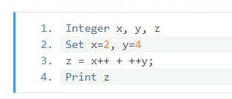

1. 6
2. 8
3. 7

Computer Fundamental(27):

Q1 Which of the following statements is/are true regarding read-only memory(ROM)?

ROM IS NON-VOLATILE

ROM CHIPS ARE NOT ONLY USED IN THE COMPUTER BUT ALSO IN OTHER ELECTRONIC ITEMS LIKE WASHING MACHINE

Programmable ROM is a read-only memory that can be modified only once by a user

Programmable ROMs are can be programmed only once and is erasable.

Choose the correct answer from the options given below.

1. Only A,B and C
2. Only D
3. Only A,B and D
4. Only A and D

Q2 Which of the following programs runs on the server machine that accepts requests from a web server and sends back the results in the form of HTML.

1. HTTP
2. HTML
3. Web Server
4. Web Site

Q3 Which of the following is/are mandatory for sending an email?

1. The body of the email
2. The recipient of the email
3. The subject of the email
4. The signature of the email

Choose the correct answer from the options given below.

1. Only 2
2. Only 1,2 and 4
3. Only 1,2 and 3
4. All 1,2,3 and 4

Q4 What will be the output of the following pseudocode?

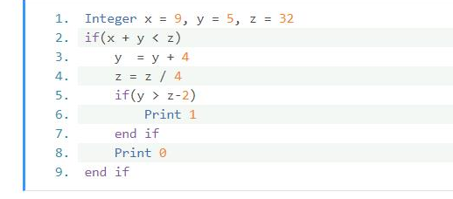

1. 1 0
2. none of the mentioned options
3. 0
4. 1

Q5 Which of the following tasks can be performed by the Database Management System(DBMS)?

1. Access database
2. Manipulate data
3. Reporting/Representation of data

Choose the correct answer from the options given below.

1. Only 2 and 3
2. All 1,2 and 3
3. Only 1
4. Only 2

Q6 Suppose there is a table-Student(SID,NAME,MARKS).If we want to calculate average marks of the students,then which of the following queries will be correct to do so?

1. Select AVG(marks) from students
2. Select COUNT(marks) from students
3. Select SUM(marks) from students
4. Select MEAN(marks) from students

Q7 Which of the following DBMS language components can be embedded in a program?

1. DBA
2. DDL
3. DML
4. None

Q8 Which of the following opertaions is/are performed by BIOS when you turn on a PC?

1. it manages data flow between the computer's operating system and attached devices such as the hard disk,video card,keyboard,mouse,and printer
2. It first conductc a basic hardware check,called a Power-On- self Test(POST)
3. All of the mentioned
4. It loads the operating system into yours computer random access memory.

Q9 Whichof the following are the different worksheet views in MS Excel?

1. Page Layout View
2. Page Break Preview
3. All of the mentioned options
4. Normal view

Q10 What will be the output of the following pseudocode for count=5?

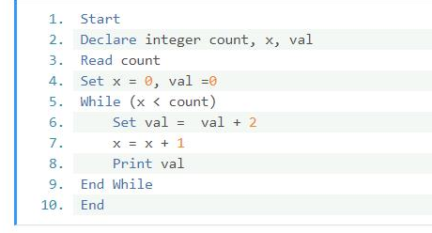

1. 0 2 4 6 8
2. 2 4 6 8 10
3. 0 1 3 5 7
4. 1 3 5 7 9

Q11 Which of the following syntax represents a root directory?

1. c:\
2. c\:\
3. c\:
4. c:\\

Q12 Data centralization can be achieved by which of the following systems?

1. DBMS
2. FMS

Choose the correct answer

1. Only 1
2. Only 2
3. Both 1 and 2
4. Neither 1 nor 2

Q13 Suppose you have the following details of a student and you wish to form a table:

1. Roll number
2. Name
3. Marks
4. Address

which of the following can be considered as a primary key of the tbale?

1. Only 1
2. Only 2
3. Only 1 and 2
4. All 1,2,3 and 4

Q14 Before the '@',what is the first part of the email called?

1. Domain name
2. User name
3. Password
4. None

Q15 Which of the following statements is true regarding Switch?

1. Dynamic connections are created by switch and provides information only to the requesting port.
2. Switches are located at gateway and forwards data packets.

Choose the correct answer from the options.

1. Only 1
2. Only 2
3. both 1 and 2
4. Neither 1 nor 2

Computer Fundamental: 29

Q1 Which of the following are the types of system software?

1. Language processor
2. Operating System
3. Device Drivers
4. All of the mentioned

Q2 What will be the output of the following pseudocode for a=2?

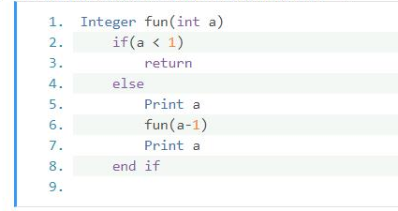

1. 2 1 1 2
2. 3 2 1 1 2 3
3. 2 1
4. 1 2

Q3 Which of the following is used to represent a set of columns whose values uniquely identify every row of a table?

1. Composite key
2. Unique key
3. Foreign key
4. Primary key

Q4 Which of the following is an attribute of an ER-Model?

1. age
2. email_address
3. first_name
4. All of the mentioned

Q5 DBMS is a set of ______that helps user to create and manage a database.

1. programs
2. keys
3. data
4. translator

Q6 Which of the following types of VPN is useful for connecting remote offices using shared infrastructure with the same policy as a private network?

1. Extranet VPN
2. Access VPN
3. Intranet VPN
4. None of the mentioned

Q7 Which of the following commands will you use to display a full list of file names extensions and program associations?

1. driverquery
2. assoc
3. relprg
4. cipher

Q8 In which of the following memory chips,the BIOS STORES THE DATE,THE TIME,AND THE SYSTEM CONFIGURATION INFORMATION?

1. Motherboard
2. MOS
3. ROM chips
4. CMOS

Q9 Suppose you have the following details of a student and you wish to form a table:

1. Roll number
2. Name
3. Marks
4. Address

Which of the following can be considered as a primary key of the table?

1. Only 1
2. Only 2
3. Only 1 and 2
4. All 1,2,3 and 4

Q10 Which of the following are the disadvantages of File management system?

1. Does not support multi-user access
2. Redundancy and Integrity issues
3. Requires highly skilled administrators

Choose the correct answer from the options given below.

1. Only 1 and 2
2. Only 3 and 2
3. Only 1 and 3
4. All 1 ,2 and 3

Q11 Which of the following is responsible for transferring and routing an electronic mail message from the sender's computer to the recipient's computer?

1. MAPI
2. Mail server
3. Message transfer Agent
4. POP3

Q12 Which of the following are the linkage points of an Ethernet Network?

1. Bridges
2. Gateways
3. Switches
4. Router

Q13 Which of the following can be added to the signature of the email?

1. Text
2. Link
3. Image

Choose the correct answer from the options given below.

1. All 1,2 and 3
2. Only 1 and 3
3. Only 2 and 3
4. Only 1 and 2

Q14 What will be the output of the following code?

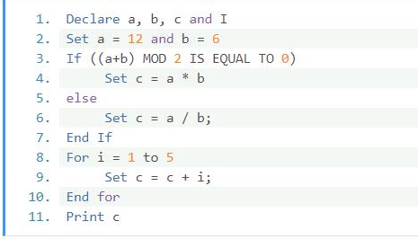

1. 87
2. 12
3. 6
4. 2

Q15 Which of the following operations are performed by BIOS when you turn a PC?

1. It firsts conducts a basic hardware check called a Power-On-Self-Test(POST)
2. It manages the data flow between the computer's operating system and attached devices such as the hard disk,video card,keyboard and printer.
3. It loads the operating system into your computer's random access memoty
4. All of the mentioned options